Training Data Set Creation

The training data set used for this analysis is shown below (first 5 lines):

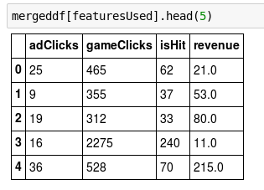

Dimensions of the final data set: 542x4



# of clusters created: 3

